S3 – Simple Storage Service

1. This service is the first service of AWS.
2. It is a service to store data in AWS cloud environment.
3. S3 service is free for upto 5GB. Beyond that charges apply.
4. S3 service is Global.

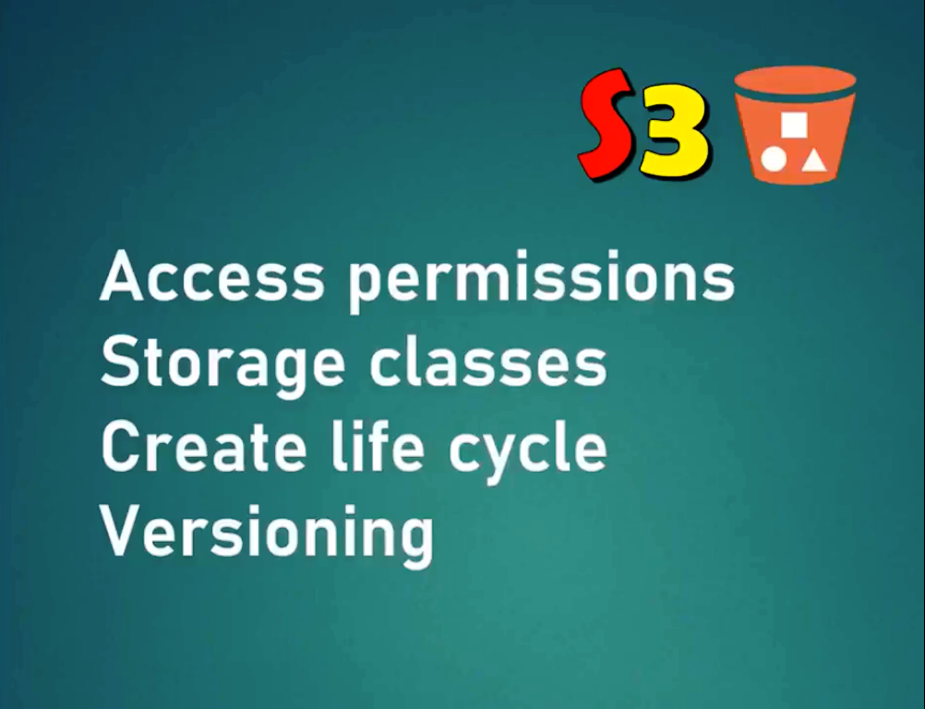

Hands On:

Creating S3 Bucket:

1. Log in to AWS IAM console, and select S3 service.
2. Click on ‘Create Bucket’ to create a new storage.
3. Bucket Name: Bucket name should be globally independent.
4. Region Name: Select a preferred region.
5. Block all public access: Enable it
6. Bucket Versioning: Just like GIT versioning
7. Click ‘CreateBucket’
8. A new bucket will be created in the selected region.
9. Select the newly create bucket and select the tab ‘Permissions’.
10. Here you can notice that all the permissions are blocked for public access.

Upload file to Bucket:

1. Select your S3 bucket.
2. Under Objects tab , click on the button ‘Upload’.
3. Select ‘Add file’ or ‘Add folder’.
4. Select a file to upload and click ‘Upload’.

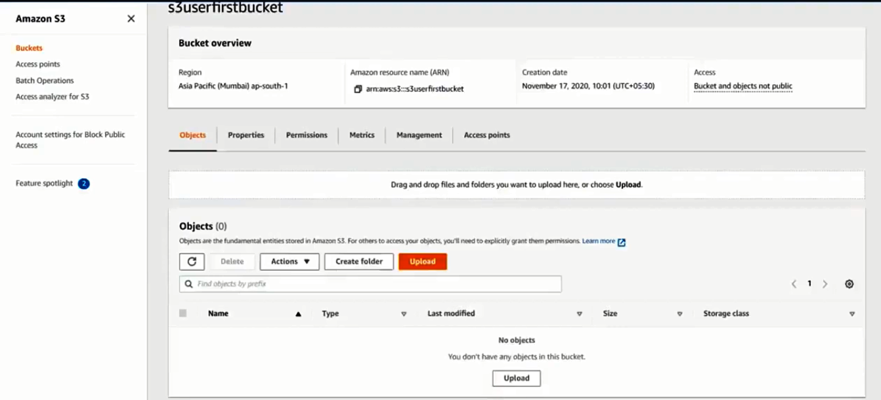

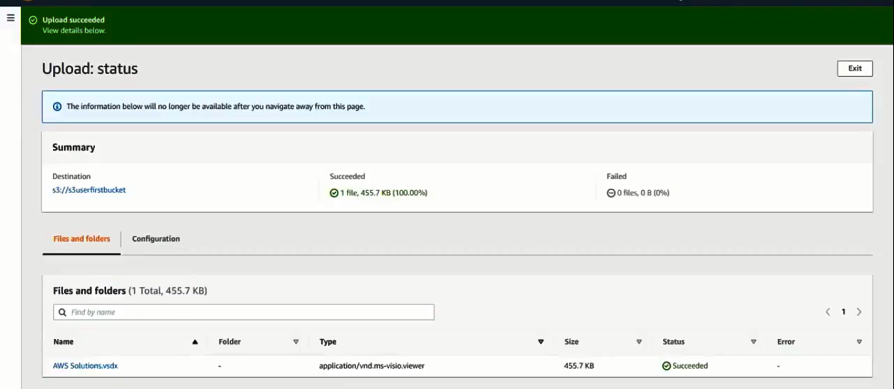

Versioning:

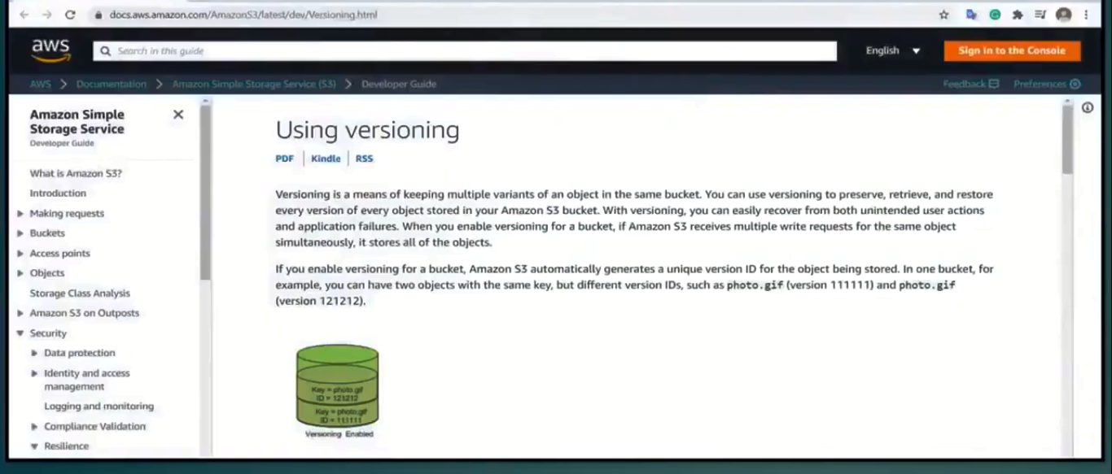

1. Maintaining multiple file copies with updated data with same name is called versioning.
2. For each update we create a new version of the file, and maintain a new ID.
3. Note: If once versioning is enabled, we cannot disable or suspend it.
4. GO to console, S3 service, create a bucket, upload a file.
5. After creating the file if you open the file in console and can observe from the following images that, file is version enabled.

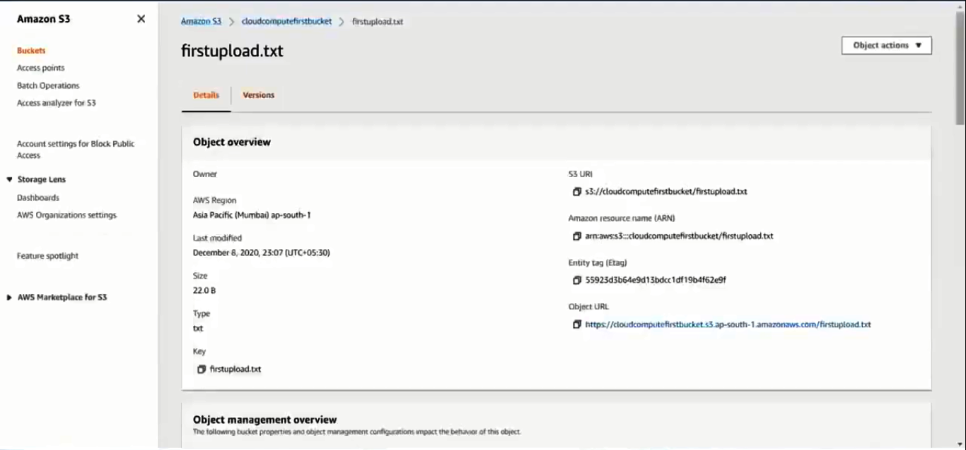

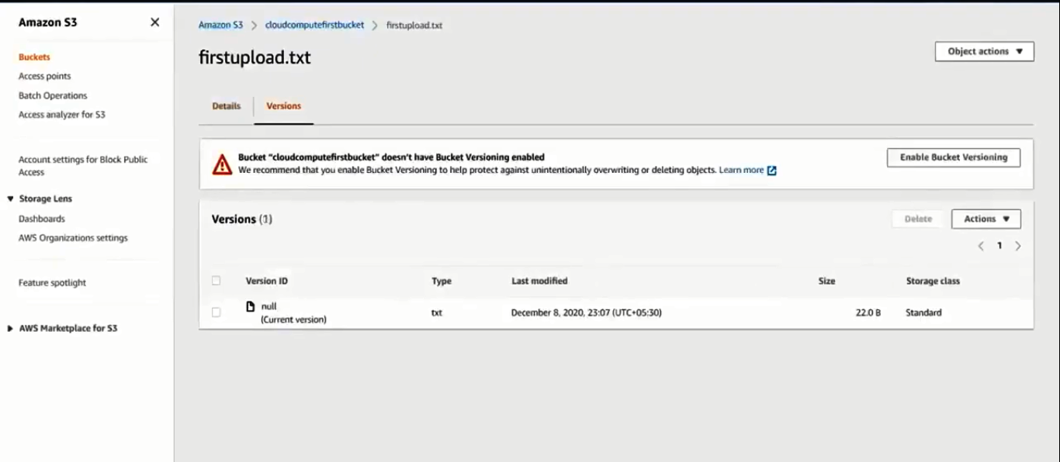

1. You can open and see the contents of the file in console with some additional options.

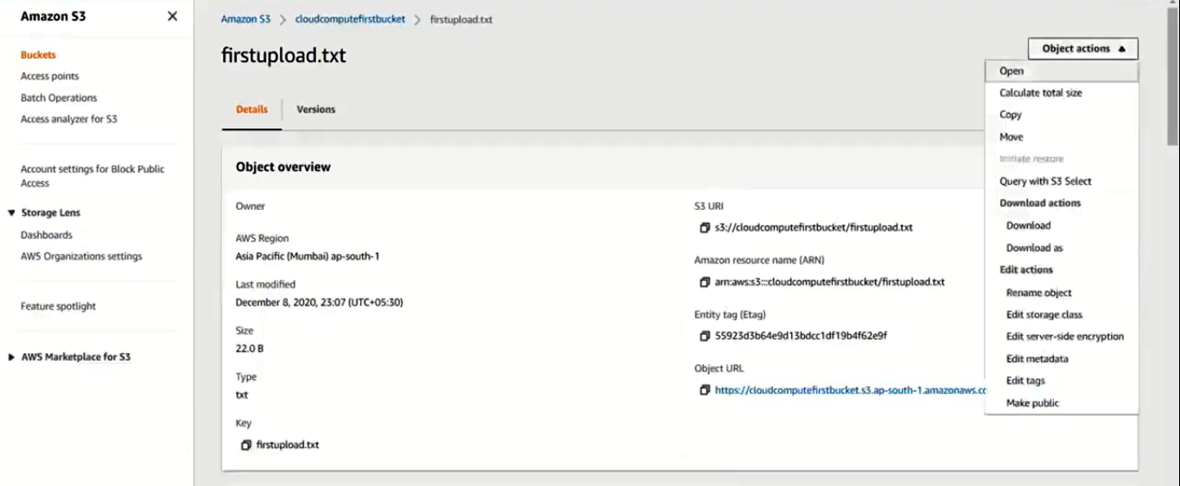



1. The file is opened in the browser, and the url used to open the file is called ‘pre signed URL’.
2. This URL will be changing after a unit of time by the AWS.
3. Now open the file manually in your system, and make some changes. And re upload.
4. The previous file will be overridden, and no version id is maintained.
5. So, we cannot get the previous file data.
6. To solve above problem, we have to enable the versioning for our S3 bucket.
7. Go and select our S3 bucket and go to the tab ‘Properties’.
8. Bucket Versioning: Edit

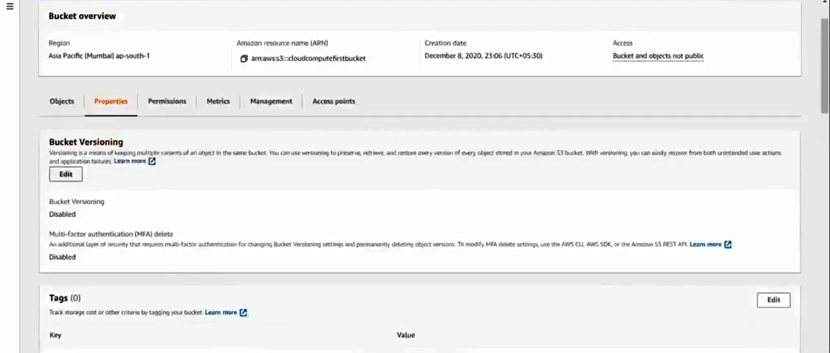

1. Enable it and save changes.
2. Now, re upload the same file again and this time you can observe that the file is now versioned.

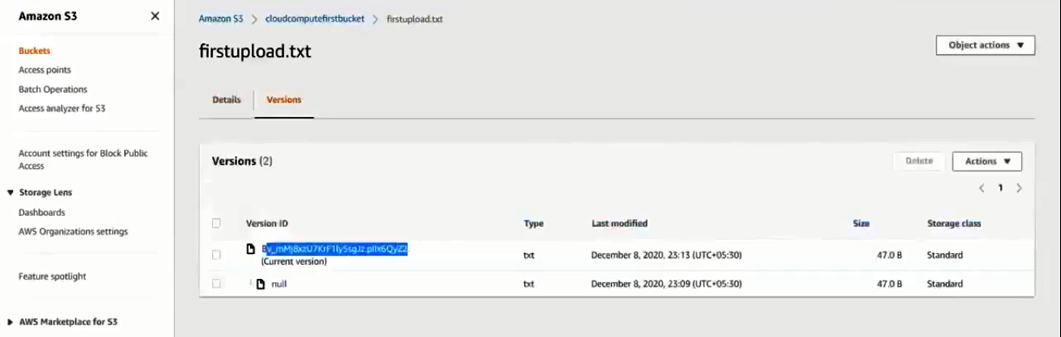

1. When ever you delete a file , in version, a delete marker will be created and the file is not actually deleted.
2. Because you may want the deleted file to restore again.
3. So , select the delete marker and delete it.
4. This way we can restore the file.
5. If you do want to delete the file permanently, then just do not delete the ‘delete marker’.

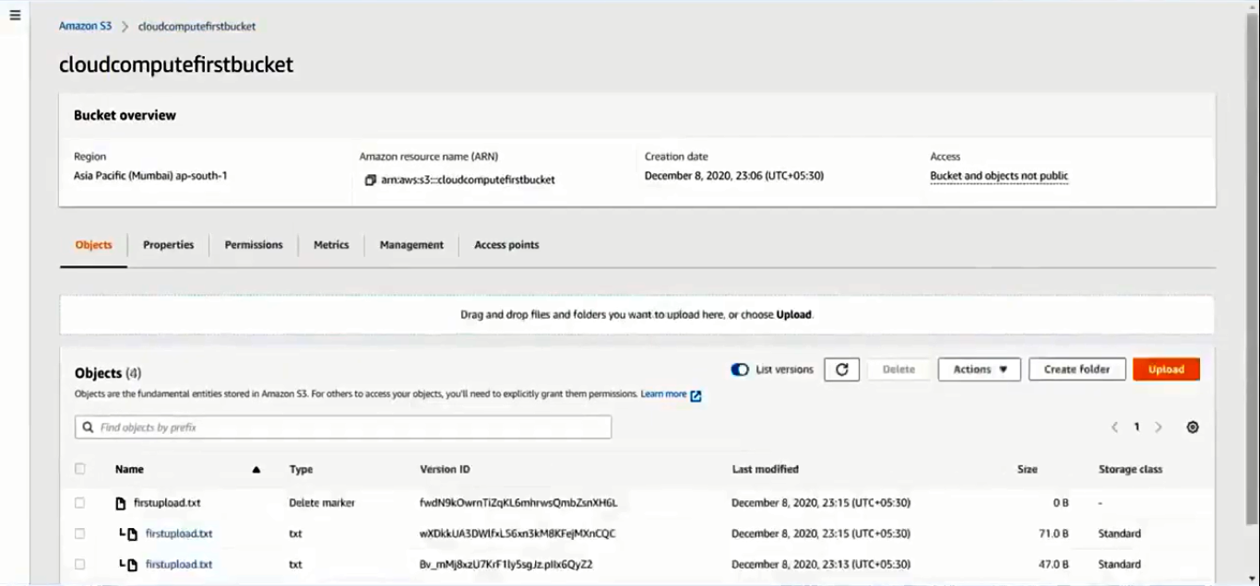

Storage Classes and Life Cycle Mgmt.:

1. S3 maintains different Storage Classes to store our data.
2. Each storeage type is used to maintain different priority of data.
3. If no storage class is mentioned, then the default storage class will be ‘S3-Standard’.
4. Each storage class has a different price range.

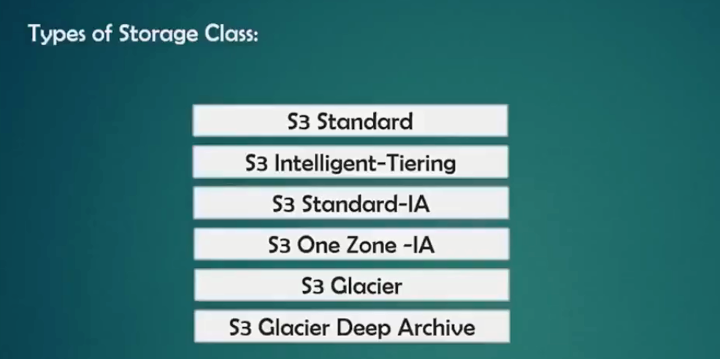

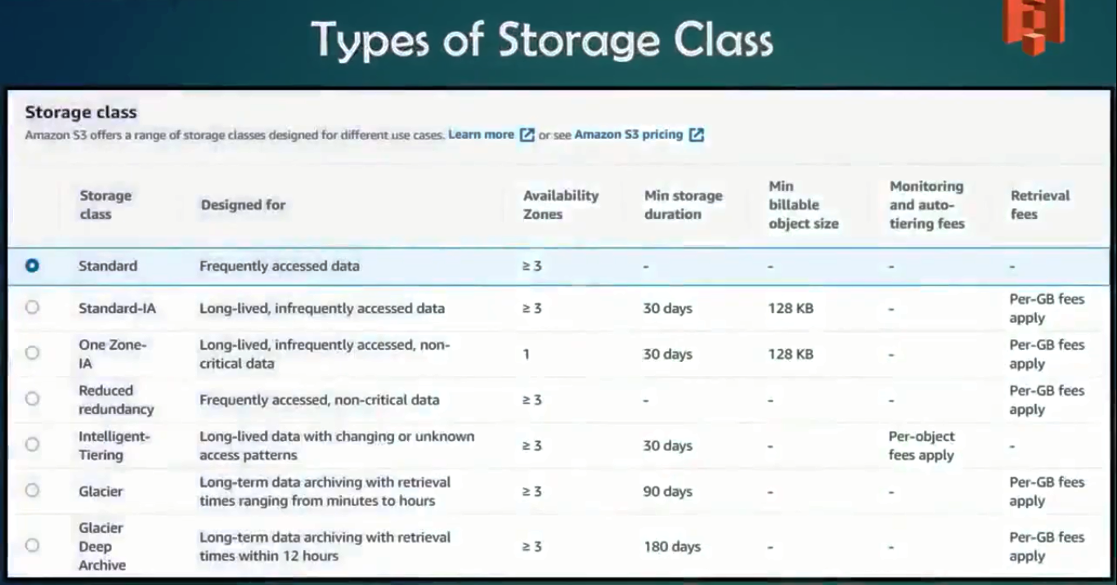

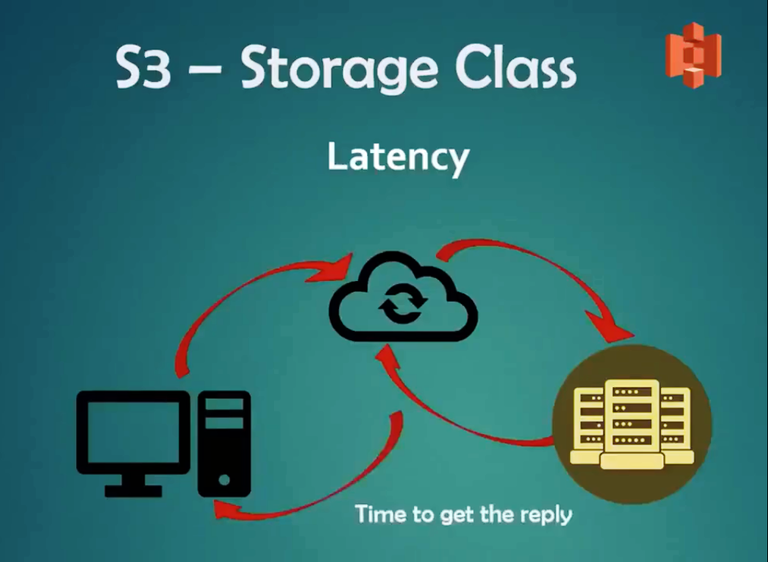

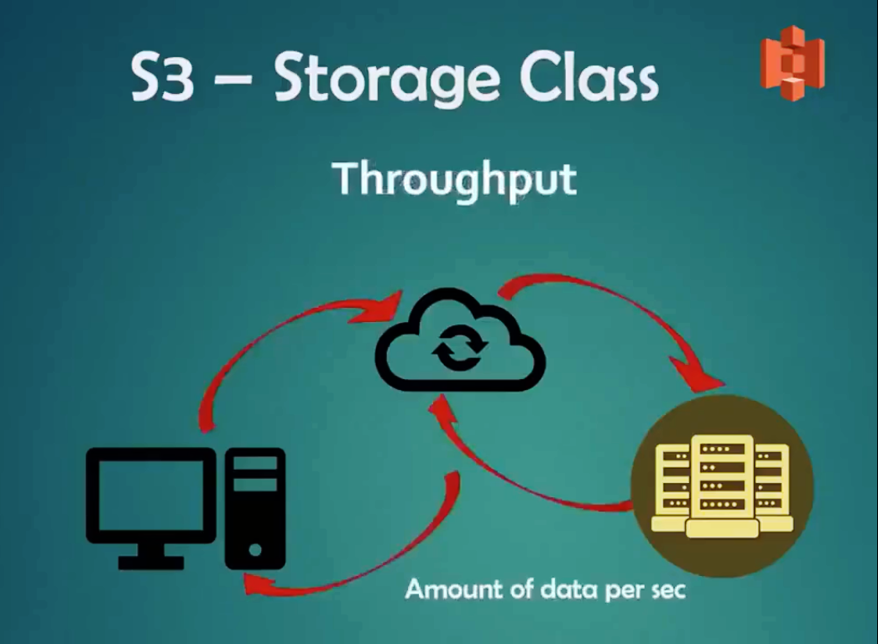

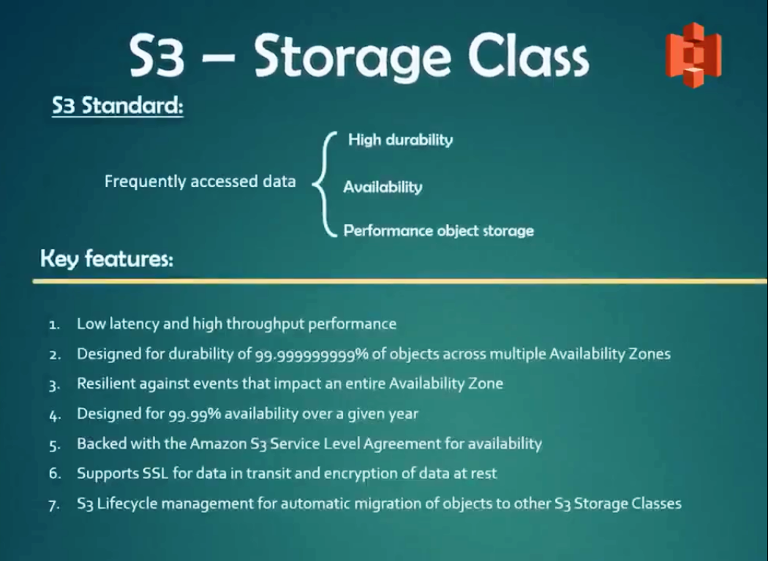

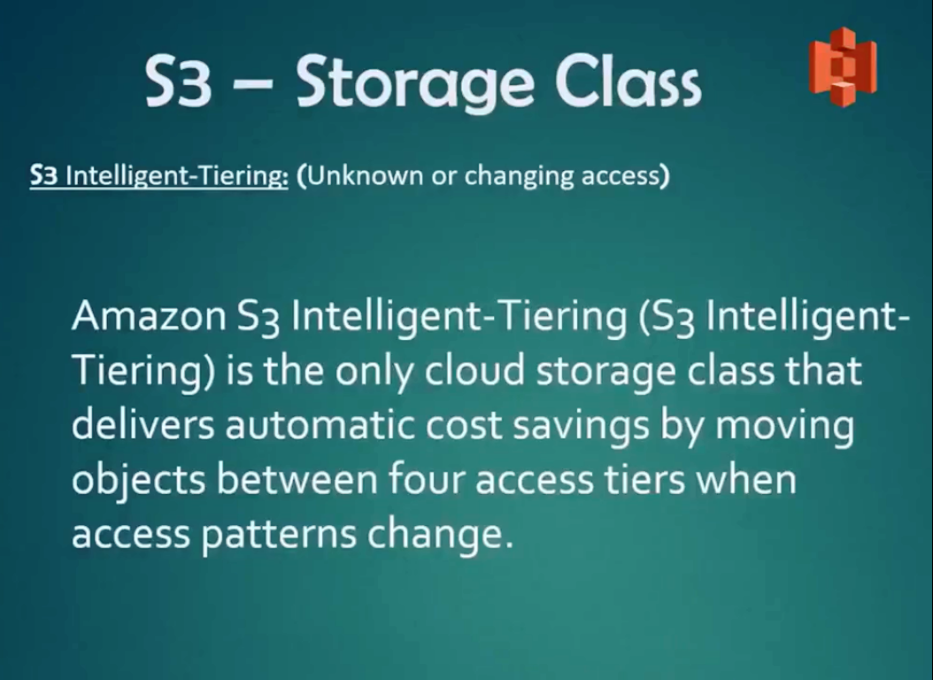

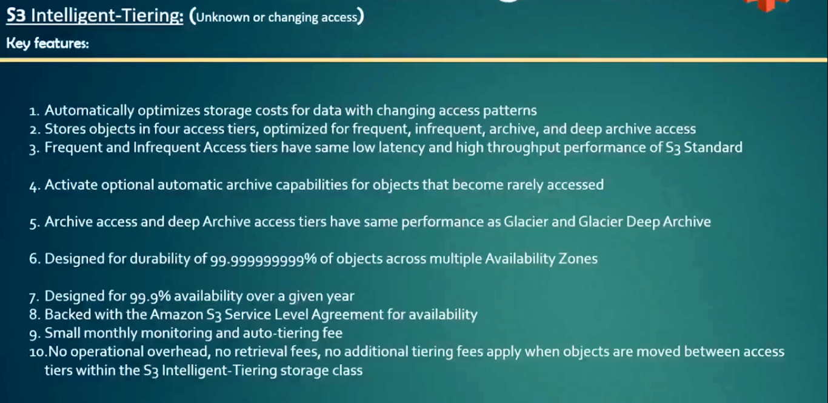

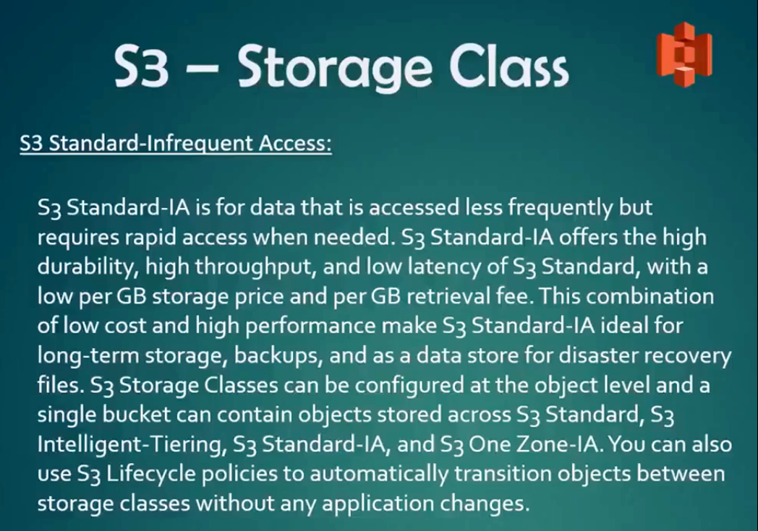

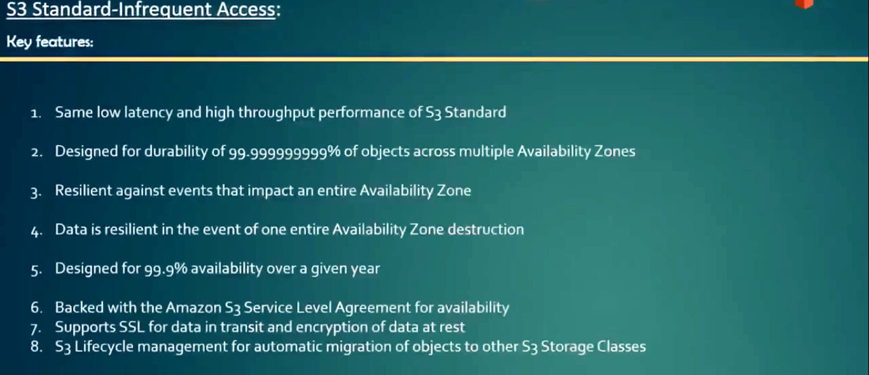

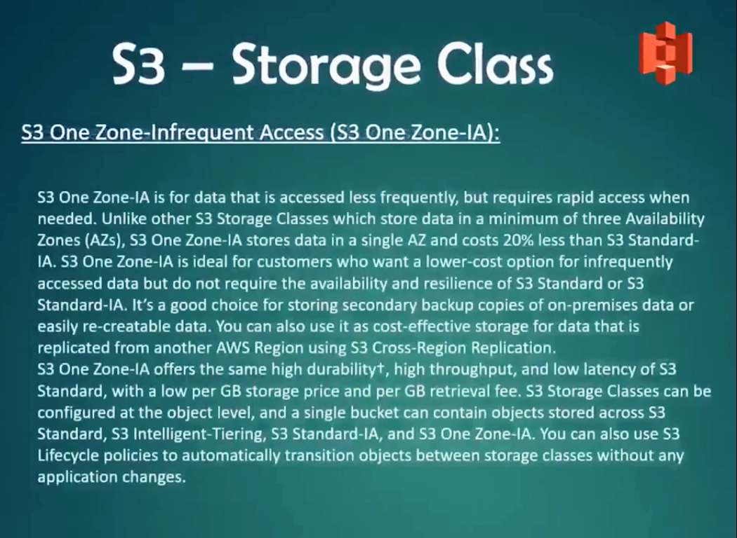

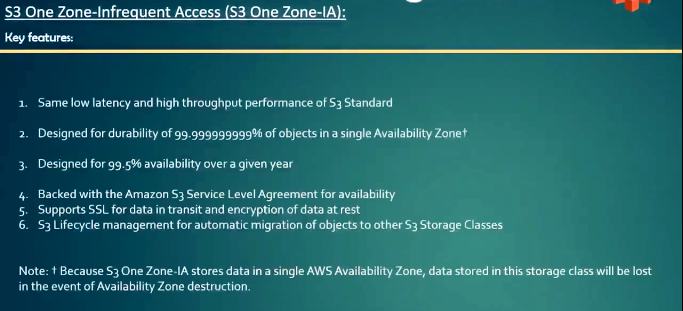

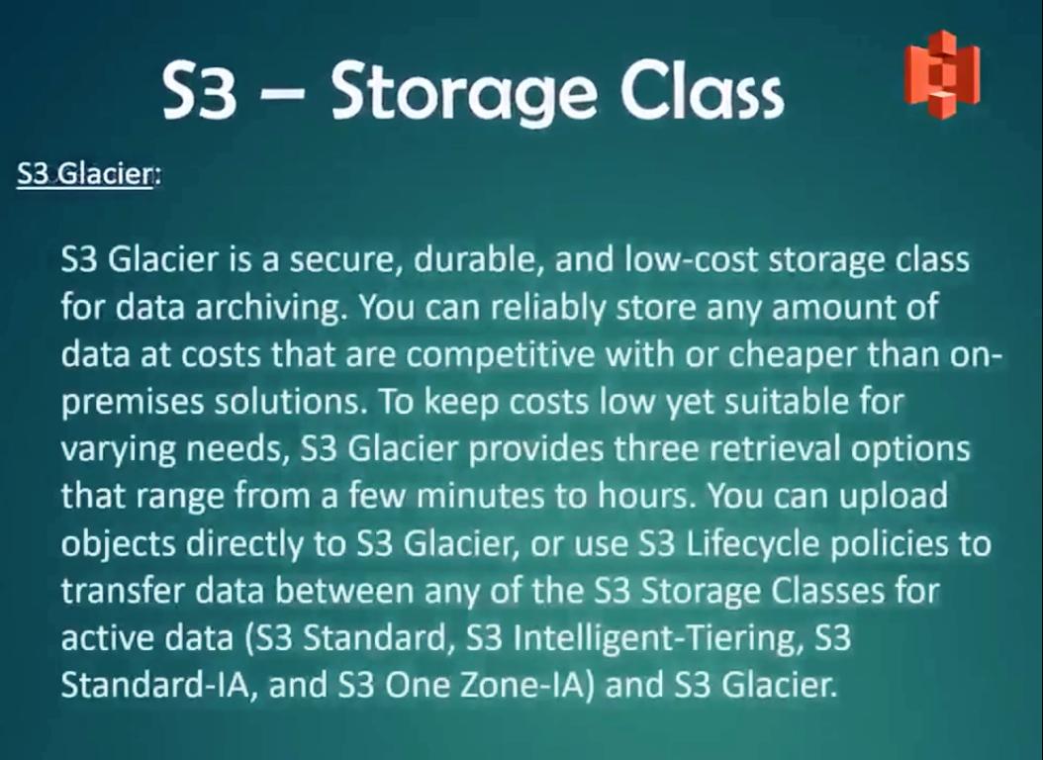

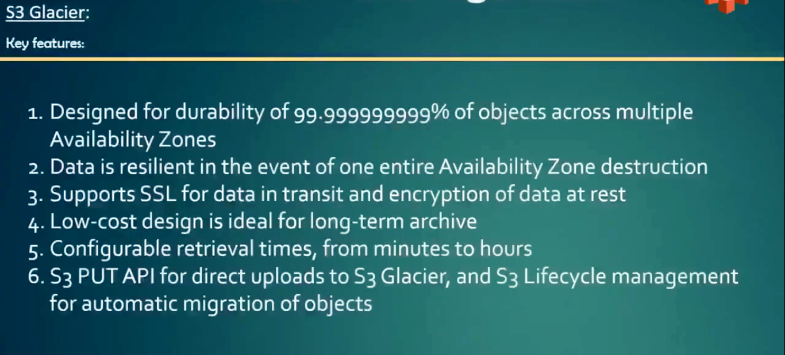

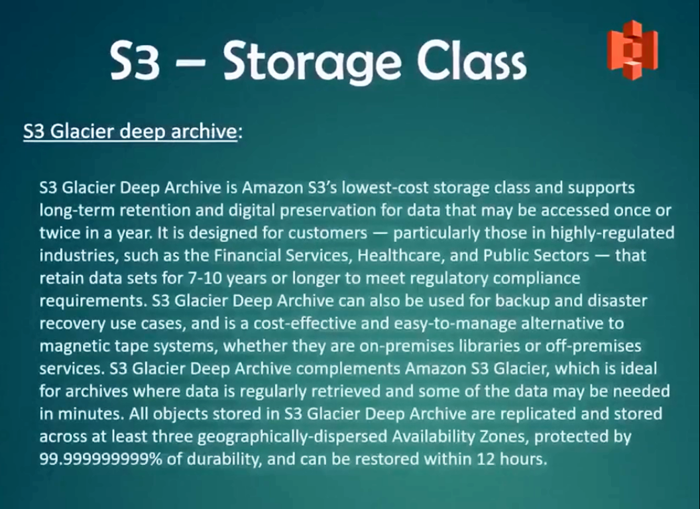

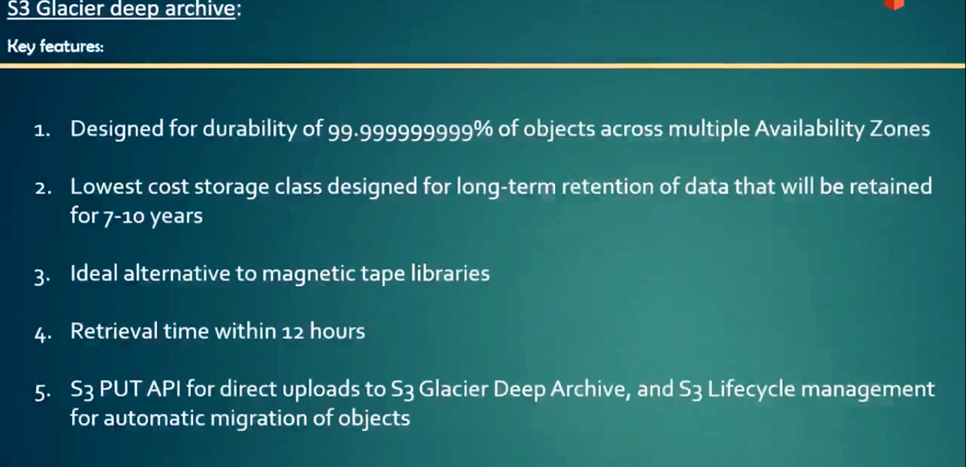

Hands On:

1. Create an S3 Bucket.
2. While uploading a file or folder in the bucket, expand the option ‘Additional Upload Options’.
3. Here, we can find different storage classes to select.
4. Default storage class is Standard.
5. Try to upload 2 or more files independently using different storage classes.
6. For example, one file in standard and another is glacier.
7. You must enable ‘Life Cycle mgmt’ service in order to apply storage classes.

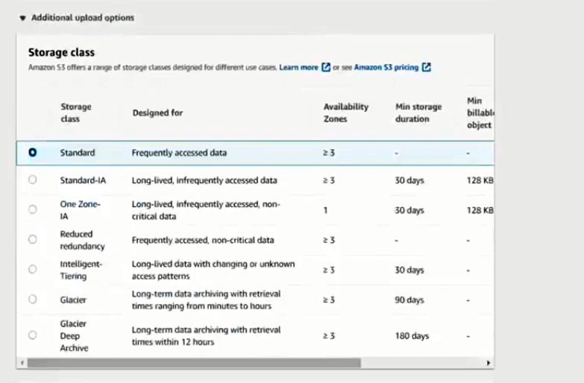

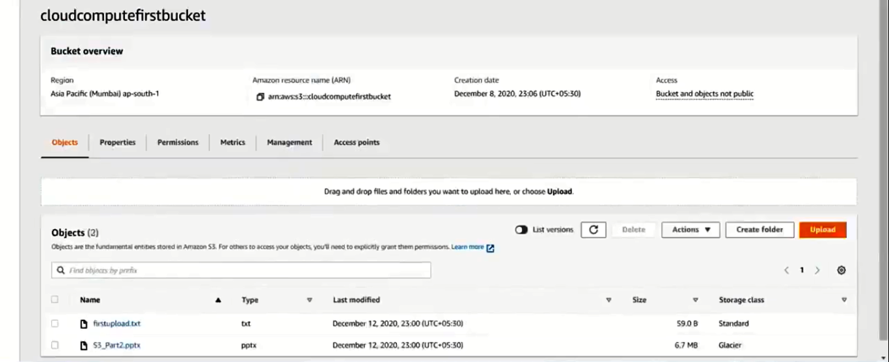

NOTE: Life Cycle Management can be done of a single file, or single folder or for an entire S3 bucket.

Setting Life Cycle Management in S3 service:

1. Select your S3 bucket.
2. Under tabs, select ‘Management’ tab.
3. Click button ‘Create life cycle rule’.

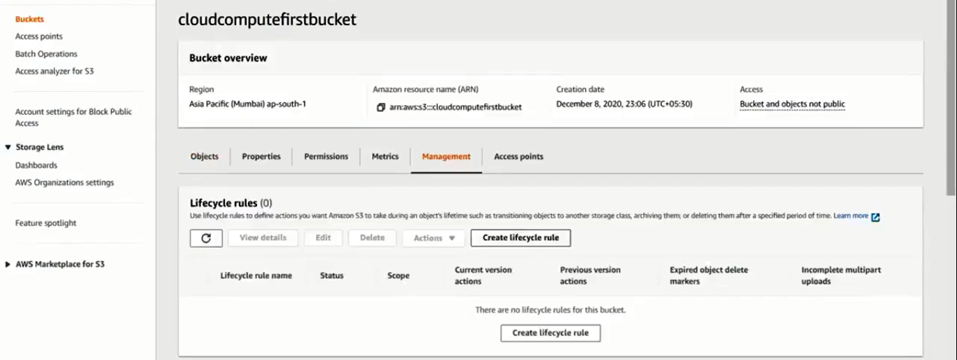

1. Life Cycle Rule Name: MyMovingFiles
2. Choose a Rule Scope: This rule applies to all objects in the bucket

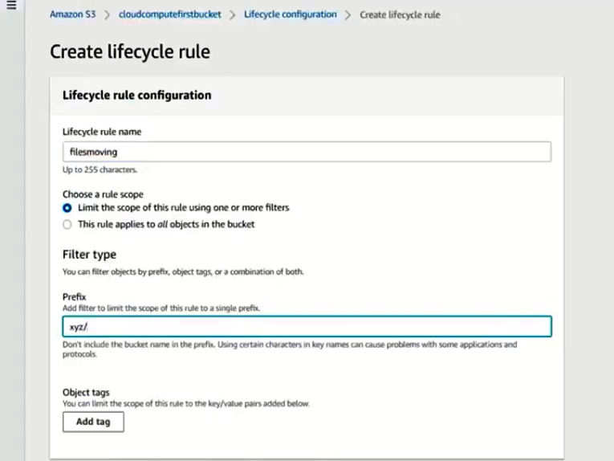

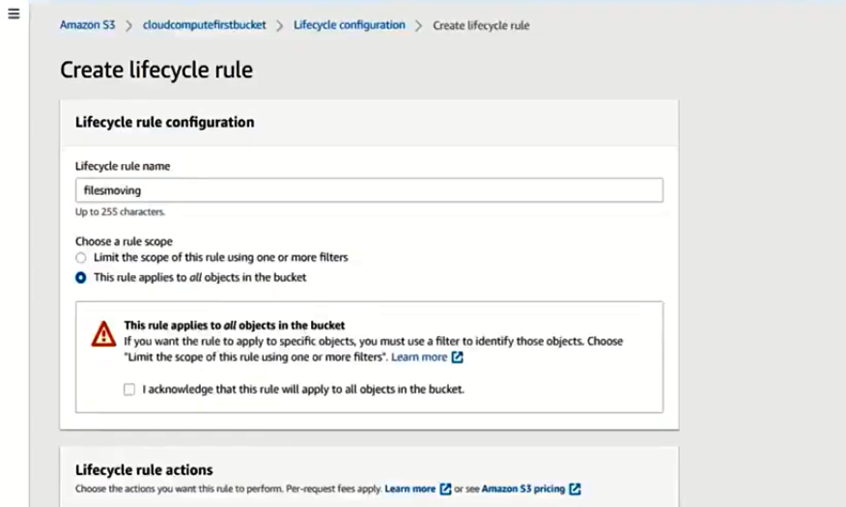

1. Life Cycle Rule actions: optional (but good to know).

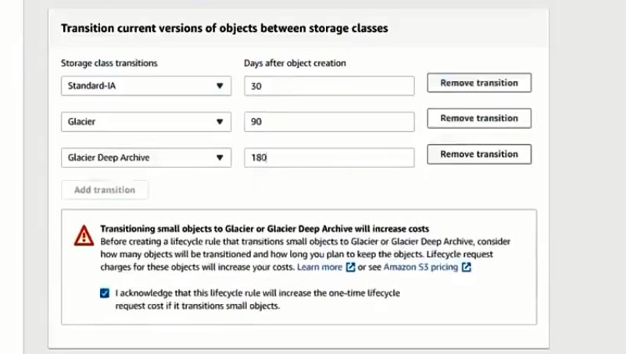

1. Finally click on ‘Create Rule’.

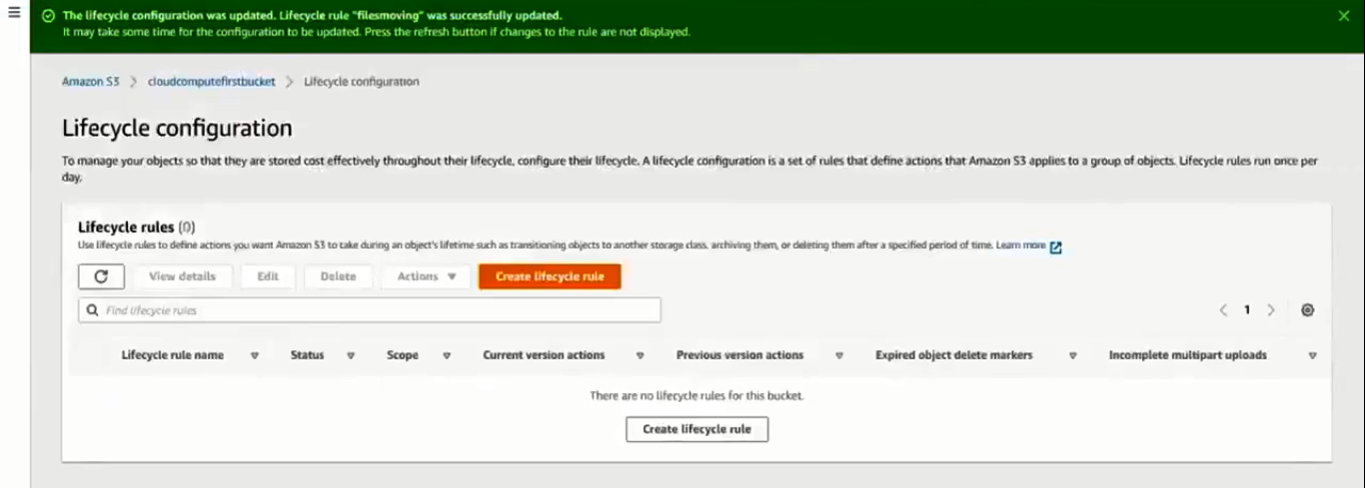

Encryption in S3:

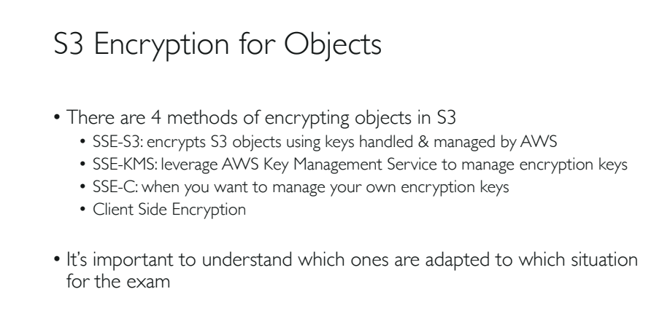

Hands On:

1. Create 3 users in your aws root account.

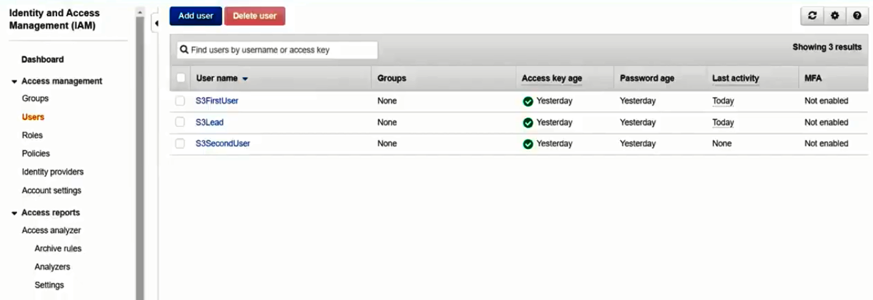

1. Assign **AmazonS3FullAccess** to all the users in ‘IAM’, ‘Users’ screen.

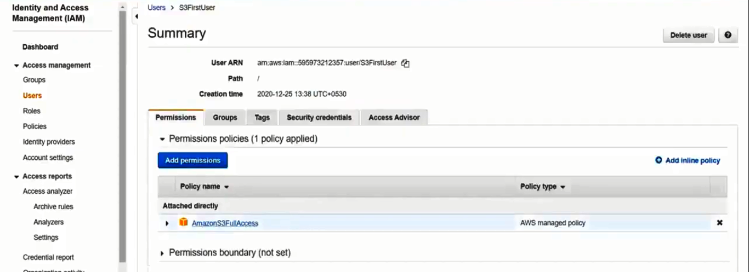

1. Task:
   1. Only Lead account should access a particular S3 bucket, no other should access.
   2. Remaining S3 buckets should be accessed by all the users.
2. To achieve the above task, go to KMS, generate a key and attach this key to the Lead user.
3. Follow the attached images for this.

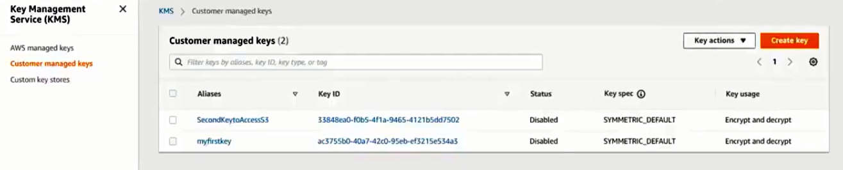

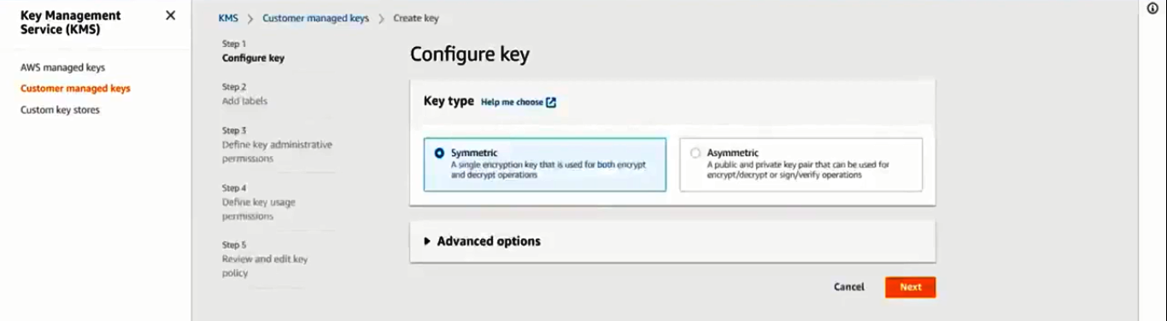

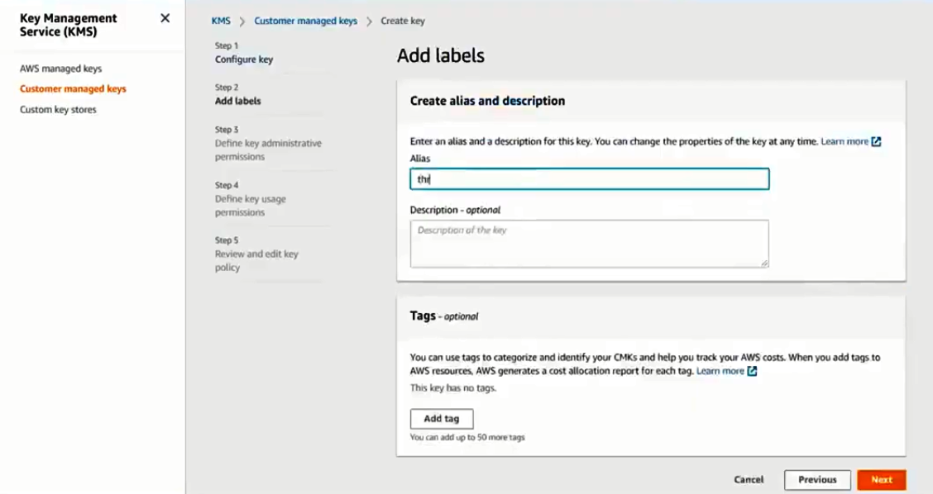

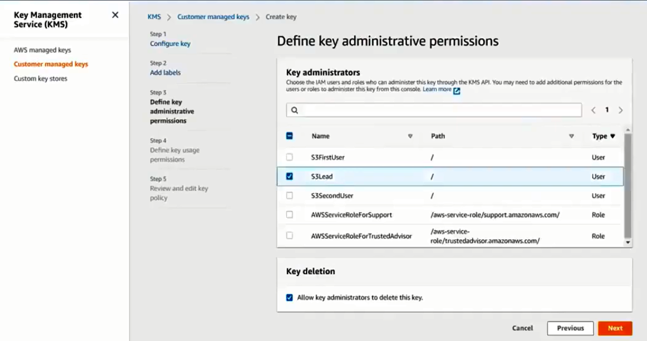

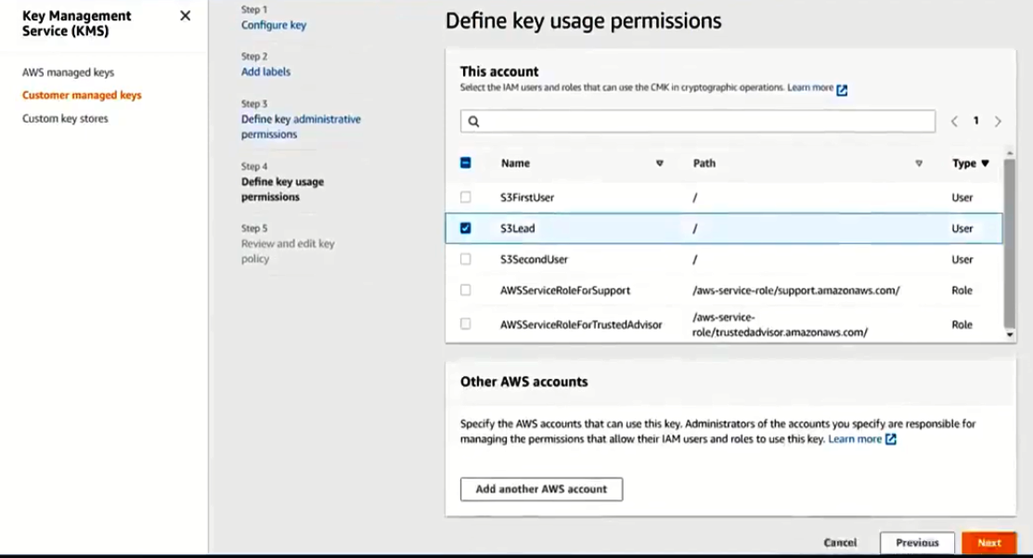

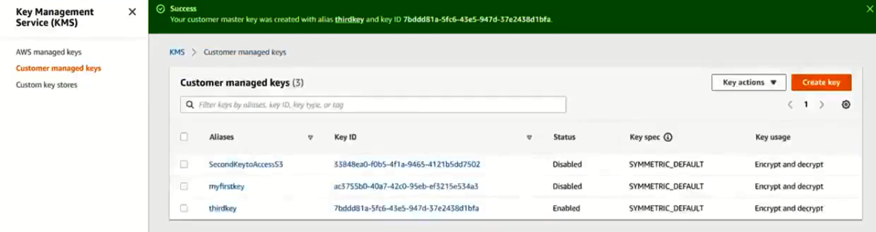

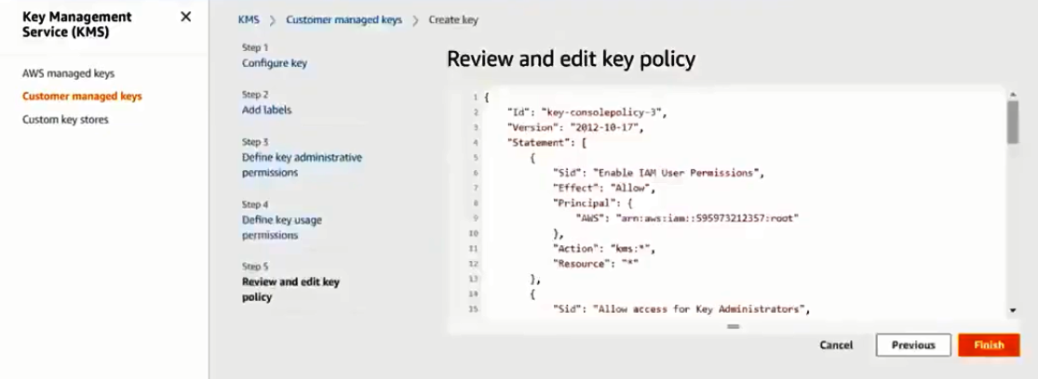

1. The above steps will create a KMS key and allows access to selected S3 bucket only to ‘Lead’ user.
2. Now we login through ‘Lead’ user and see weather we can upload, download and read files.
3. Then we login through rest of the two new users and check the above operations again.
4. Open a new mgmt console in an another browser.
5. Login the console with Lead account.
6. Create a new bucket using your root account.
7. While creating the bucket, change the ‘Default Encryption’ settings.

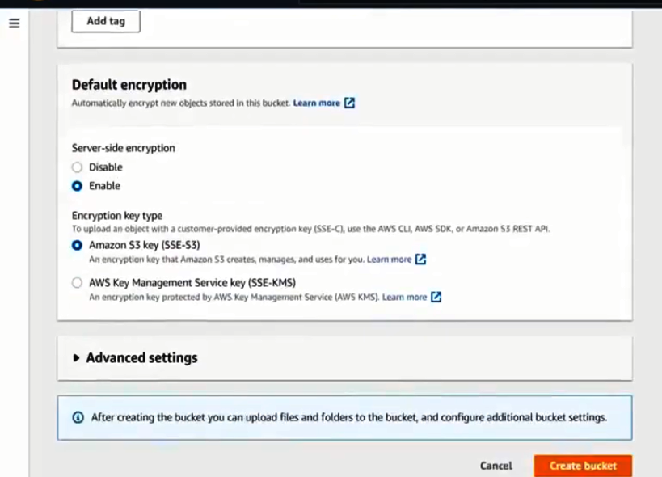

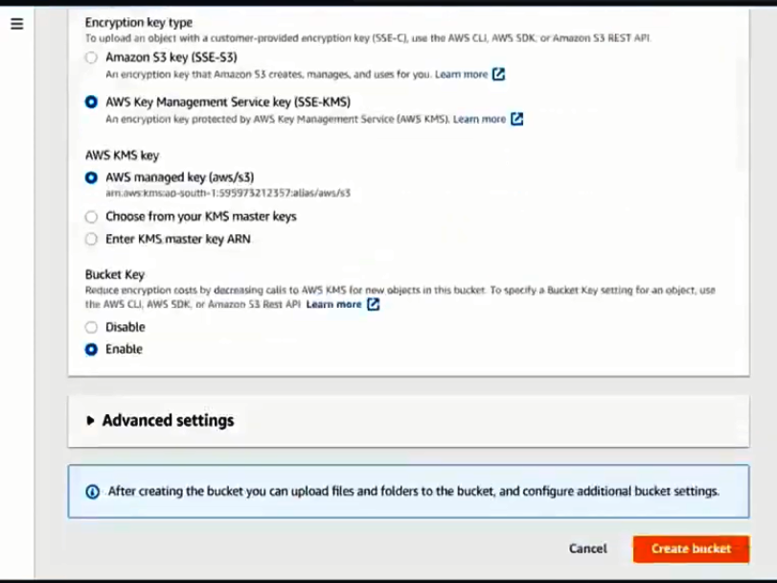

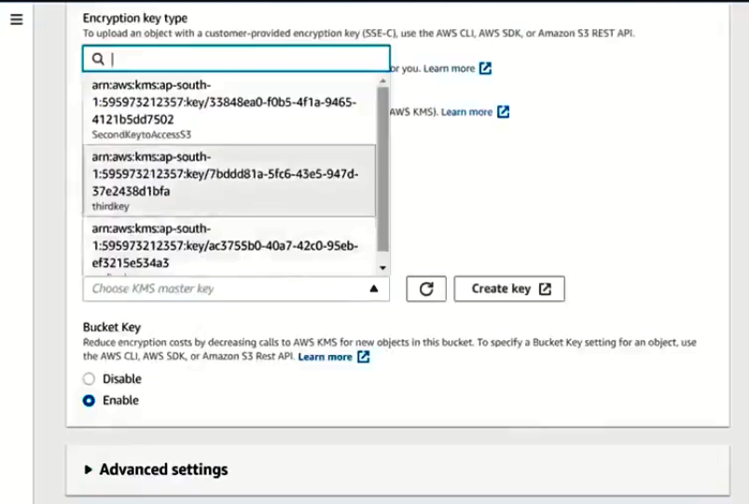

1. Finally click ‘Create Bucket’.
2. Now access the above created bucket using the ‘Lead’ account.
3. Check can you read files from S3 bucket or not.
4. You should have access to the S3 Bucket from ‘Lead’ user.
5. Now do the same operations using the other accounts which doesn’t have KEM key.
6. Except ‘Lead’ user no other account could access the S3 bucket.